I have been doing more topic modeling in various projects, so I wanted to share some workflows I have found useful for

* training many topic models at one time,
* evaluating topic models and understanding model diagnostics, and
* exploring and interpreting the content of topic models.

Topic Modelling of Sherlock Homes Stories

.

library(tidyverse)

library(gutenbergr)

sherlock_raw <- gutenberg_download(1661)

sherlock <- sherlock_raw %>%

mutate(story = ifelse(str_detect(text, "ADVENTURE"),

text,

NA)) %>%

fill(story) %>%

filter(story != "THE ADVENTURES OF SHERLOCK HOLMES") %>%

mutate(story = factor(story, levels = unique(story)))

sherlock

## # A tibble: 12,624 x 3

## gutenberg_id

## <int>

## 1 1661

## 2 1661

## 3 1661

## 4 1661

## 5 1661

## 6 1661

## 7 1661

## 8 1661

## 9 1661

## 10 1661

## text story

## <chr> <fct>

## 1 ADVENTURE I. A SCANDAL IN BOHEMIA ADVENTURE I. A SCANDA…

## 2 "" ADVENTURE I. A SCANDA…

## 3 I. ADVENTURE I. A SCANDA…

## 4 "" ADVENTURE I. A SCANDA…

## 5 To Sherlock Holmes she is always THE woman… ADVENTURE I. A SCANDA…

## 6 him mention her under any other name. In h… ADVENTURE I. A SCANDA…

## 7 and predominates the whole of her sex. It … ADVENTURE I. A SCANDA…

## 8 any emotion akin to love for Irene Adler. … ADVENTURE I. A SCANDA…

## 9 one particularly, were abhorrent to his co… ADVENTURE I. A SCANDA…

## 10 admirably balanced mind. He was, I take it… ADVENTURE I. A SCANDA…

## # ... with 12,614 more rows

Next, let’s transform this text data into a tidy data structure using unnest_tokens(). We can also remove stop words at this point because they will not do us any favors during the topic modeling process. Using the stop_words dataset as a whole removes a LOT of stop words; you can be more discriminating and choose specific sets of stop words if appropriate for your purpose. Let’s also remove the word “holmes” because it is so common and used neutrally in all twelve stories.

library(tidytext)

tidy_sherlock <- sherlock %>%

mutate(line = row_number()) %>%

unnest_tokens(word, text) %>%

anti_join(stop_words) %>%

filter(word != "holmes")

tidy_sherlock %>%

count(word, sort = TRUE)

## # A tibble: 7,437 x 2

## word n

## <chr> <int>

## 1 time 151

## 2 door 144

## 3 matter 125

## 4 house 123

## 5 hand 120

## 6 night 114

## 7 heard 113

## 8 found 108

## 9 day 106

## 10 morning 102

## # ... with 7,427 more rows

What are the highest tf-idf words in these twelve stories? The statistic tf-idf identifies words that are important to a document in a collection of documents; in this case, we’ll see which words are important in one of the stories compared to the others.

library(drlib)

sherlock_tf_idf <- tidy_sherlock %>%

count(story, word, sort = TRUE) %>%

bind_tf_idf(word, story, n) %>%

arrange(-tf_idf) %>%

group_by(story) %>%

top_n(10) %>%

ungroup

sherlock_tf_idf %>%

mutate(word = reorder_within(word, tf_idf, story)) %>%

ggplot(aes(word, tf_idf, fill = story)) +

geom_col(alpha = 0.8, show.legend = FALSE) +

facet_wrap(~ story, scales = "free", ncol = 3) +

scale_x_reordered() +

coord_flip() +

theme(strip.text=element_text(size=11)) +

labs(x = NULL, y = "tf-idf",

title = "Highest tf-idf words in Sherlock Holmes short stories",

subtitle = "Individual stories focus on different characters and narrative elements")

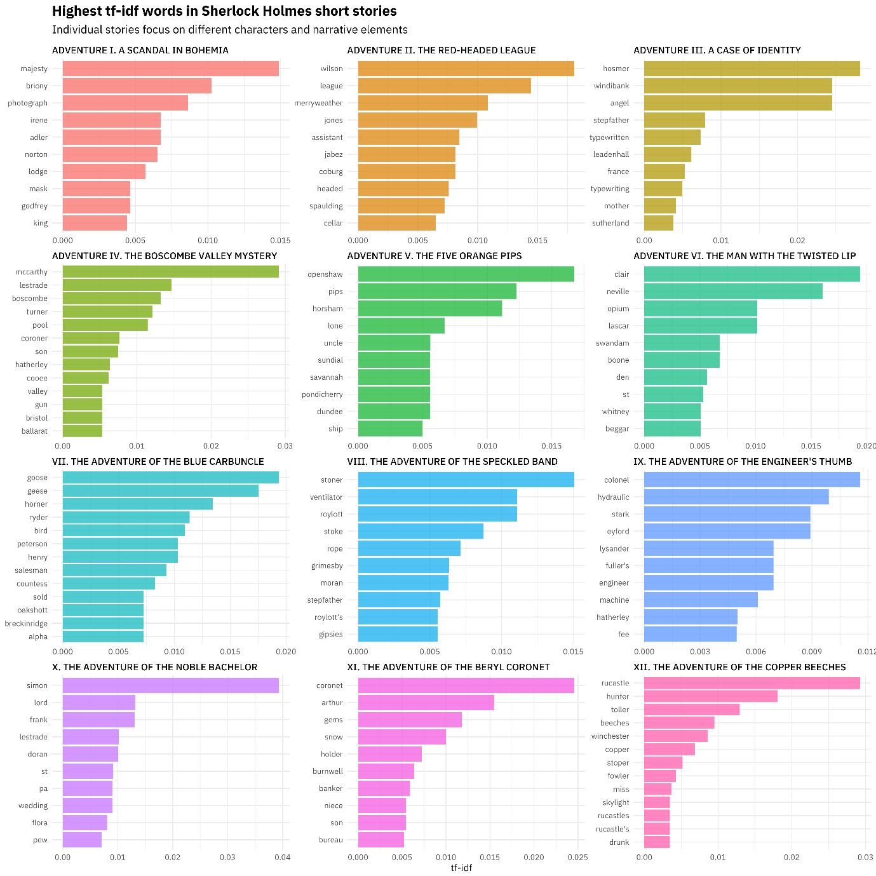

We see lots of proper names here, as well as specific narrative elements for individual stories, like GEESE. 🐦 Exploring tf-idf can be helpful before training topic models.

Speaking of which… let’s get started on a topic model! I am really a fan of the stm package these days because it is easy to install (no rJava dependency! 💀), it is fast (written in Rcpp! 😎), and I have gotten excellent results when experimenting with it. The stm() function take as its input a document-term matrix, either as a sparse matrix or a dfm from quanteda.

library(quanteda)

library(stm)

sherlock_dfm <- tidy_sherlock %>%

count(story, word, sort = TRUE) %>%

cast_dfm(story, word, n)

sherlock_sparse <- tidy_sherlock %>%

count(story, word, sort = TRUE) %>%

cast_sparse(story, word, n)

You could use either of these objects (sherlock_dfm or sherlock_sparse) as the input to stm(); in the video, I use the quanteda object, so let’s go with that. In this example I am training a topic model with 6 topics, but the stm includes lots of functions and support for choosing an appropriate number of topics for your model.

topic_model <- stm(sherlock_dfm, K = 6,

verbose = FALSE, init.type = "Spectral")

The stm package has a summary() method for trained topic models like these that will print out some details to your screen, but I want to get back to a tidy data frame so I can use dplyr and ggplot2 for data manipulation and data visualization. I can use tidy() on the output of an stm model, and then I will get the probabilities that each word is generated from each topic.

td_beta <- tidy(topic_model)

td_beta %>%

group_by(topic) %>%

top_n(10, beta) %>%

ungroup() %>%

mutate(topic = paste0("Topic ", topic),

term = reorder_within(term, beta, topic)) %>%

ggplot(aes(term, beta, fill = as.factor(topic))) +

geom_col(alpha = 0.8, show.legend = FALSE) +

facet_wrap(~ topic, scales = "free_y") +

coord_flip() +

scale_x_reordered() +

labs(x = NULL, y = expression(beta),

title = "Highest word probabilities for each topic",

subtitle = "Different words are associated with different topics")

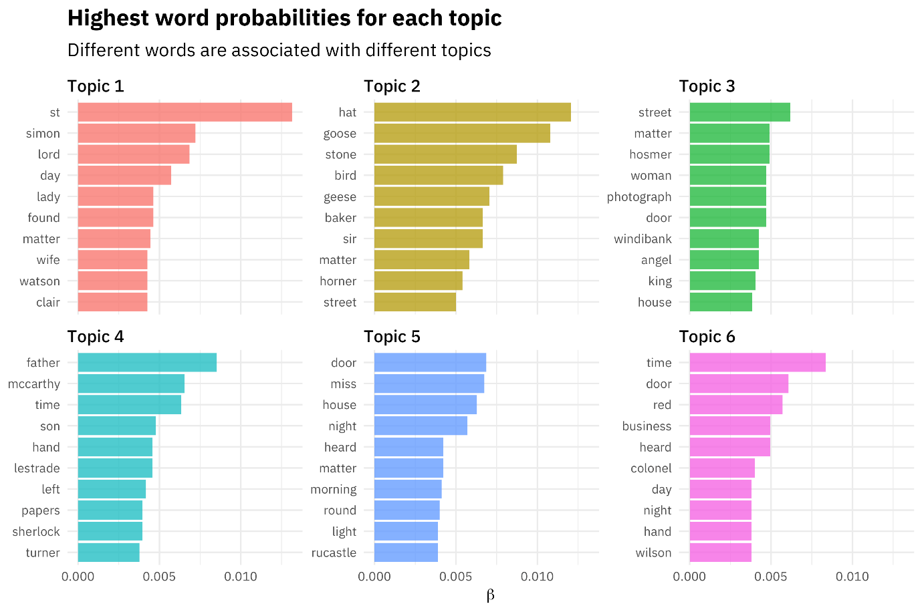

This topic modeling process is a great example of the kind of workflow I often use with text and tidy data principles.

* I use tidy tools like dplyr, tidyr, and ggplot2 for initial data exploration and preparation.
* Then I **cast** to a non-tidy structure to perform some machine learning algorithm.
* I then **tidy** the results of my statistical modeling so I can use tidy data principles again to understand my model results.

Now let’s look at another kind of probability we get as output from topic modeling, the probability that each document is generated from each topic.

td_gamma <- tidy(topic_model, matrix = "gamma",

document_names = rownames(sherlock_dfm))

ggplot(td_gamma, aes(gamma, fill = as.factor(topic))) +

geom_histogram(alpha = 0.8, show.legend = FALSE) +

facet_wrap(~ topic, ncol = 3) +

labs(title = "Distribution of document probabilities for each topic",

subtitle = "Each topic is associated with 1-3 stories",

y = "Number of stories", x = expression(gamma))

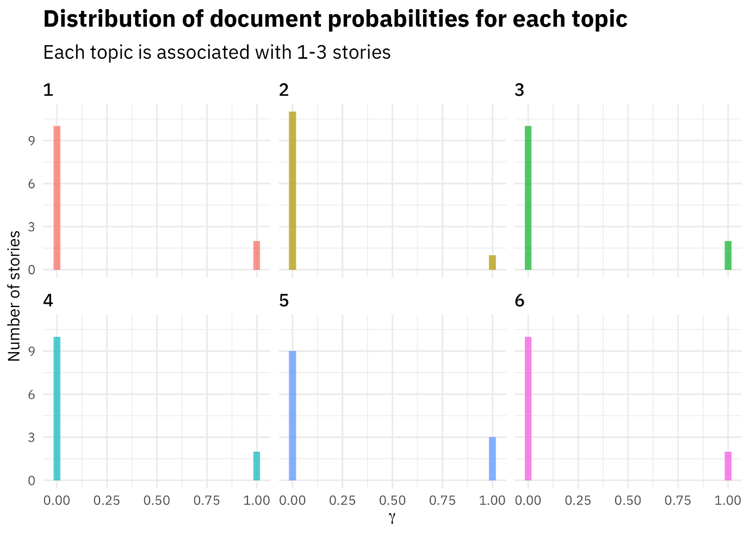

In this case, each short story is strongly associated with a single topic. Topic modeling doesn’t always work out this way, but I built a model here with a small number of documents (only 12) and a relatively large number of topics compared to the number of documents. In any case, this is how we interpret these gamma probabilities; they tell us which topics are coming from which documents.

I built a Shiny app to explore the results of this topic modeling procedure in more detail.

[](https://juliasilge.shinyapps.io/sherlock-holmes/)

We can see some interesting things; there are shifts through the collection as topic 3 stories come at the beginning and topic 5 stories come at the end. Topic 5 focuses on words that sound like spooky mysteries happening at night, in houses with doors, and events that you see or hear, topic 1 is about lords, ladies, and wives, and topic 2 is about… GEESE.

I’ve been doing all my topic modeling with Structural Topic Models and the stm package lately, and it has been ✨GREAT✨. One thing I am not going to cover in this blog post is how to use document-level covariates in topic modeling, i.e., how to train a model with topics that can vary with some continuous or categorical characteristic of your documents.

**Modeling the Hacker News corpus**

In my last blog post, I demonstrated how to get started with about a book’s worth of text, which is a TEENY TINY amount of text for a topic model. This time around, I’d like to demonstrate how to go about interpreting results with a more realistic set of text, something more like what you might actually want to model topics with in the real world, so let’s turn to the [Hacker news corpus](https://cloud.google.com/bigquery/public-data/hacker-news) and download 100,000 texts using the bigrquery package.

library(bigrquery)

library(tidyverse)

sql <- "#legacySQL

SELECT

stories.title AS title,

stories.text AS text,

FROM

[bigquery-public-data:hacker_news.full] AS stories

WHERE

stories.deleted IS NULL

LIMIT

100000"

hacker_news_raw <- query_exec(sql, project = project, max_pages = Inf)

After we have the text downloaded, let’s clean the text and make a data frame containing only the text, plus an ID to identify each “document”, i.e., post.

hacker_news_text <- hacker_news_raw %>%

as_tibble() %>%

mutate(title = na_if(title, ""),

text = coalesce(title, text)) %>%

select(-title) %>%

mutate(text = str_replace_all(text, "'|"|/", "'"), ## weird encoding

text = str_replace_all(text, "", " "), ## links

text = str_replace_all(text, ">|<|&", " "), ## html yuck

text = str_replace_all(text, "&#[:digit:]+;", " "), ## html yuck

text = str_remove_all(text, "<[^>]*>"), ## mmmmm, more html yuck

postID = row_number())

Now it’s time to tokenize and tidy the text, remove some stop words (and numbers, although this is an analytical choice that you might want to try in a different way), and then cast to a sparse matrix. I’m using the token = "tweets" option for tokenizing because it often performs the most sensibly with text from online forums, such as Hacker News (and Stack Overflow, and Reddit, and so on). Here I’m using a plain old sparse matrix. Either one works.

library(tidytext)

tidy_hacker_news <- hacker_news_text %>%

unnest_tokens(word, text, token = "tweets") %>%

anti_join(get_stopwords()) %>%

filter(!str_detect(word, "[0-9]+")) %>%

add_count(word) %>%

filter(n > 100) %>%

select(-n)

hacker_news_sparse <- tidy_hacker_news %>%

count(postID, word) %>%

cast_sparse(postID, word, n)

**Train and evaluate topic models**

Now it’s time to train some topic models!. We’re not going to train just one topic model, but a whole group of them, with different numbers of topics, and then evaluate these models. In topic modeling, like with k-means clustering, we don’t know ahead of time how many topics we should use, and research in this area says there is no “right” answer for the number of topics that is appropriate for any given corpus. Here, let’s try a number of different values for \(K\) (the number of topics) from 20 to 100.

With 100,000 texts this modeling takes a while 😩 so I have used I have used the furrr package for parallel processing.

library(stm)

library(furrr)

plan(multiprocess)

many_models <- data_frame(K = c(20, 40, 50, 60, 70, 80, 100)) %>%

mutate(topic_model = future_map(K, ~stm(hacker_news_sparse, K = .,

verbose = FALSE)))

Now that we’ve fit all these topic models with different numbers of topics, we can explore how many topics are appropriate/good/“best”. The code below to find k_result is similar to stm’s own searchK() function, but it allows you to evaluate models trained on a sparse matrix (or a quanteda dfm) instead of only stm’s corpus data structure, as well as to dig into the model diagnostics yourself in detail. Some of these functions were not originally flexible enough to take a sparse matrix or dfm as input, so I’d like to send huge thanks to Brandon Stewart, stm’s developer.

search.R Function

|  |
| --- |
| searchK <- function(documents, vocab, K, init.type = "Spectral", |
|  | N = floor(.1*length(documents)), proportion = .5, |
|  | heldout.seed = NULL, M = 10, cores = 1, ...) { |
|  |  |
|  | #Make a heldout dataset |
|  | heldout <- make.heldout(documents,vocab, N=N, proportion=proportion, |
|  | seed=heldout.seed) |
|  |  |
|  | # warnings |
|  | if( "content" %in% names(list(...)) ) { |
|  | warning("Exclusivity calculation only designed for models without content covariates", call.=FALSE) |
|  | } |
|  |  |
|  | # single core |
|  | if (cores == 1) { |
|  | g <- list() |
|  | for (i in seq_along(K)) { # loop produces nicer printout than lapply |
|  | g[[i]] <- get_statistics(K[i], heldout=heldout, init.type=init.type,M=M,...) |
|  | } |
|  | # multi core |
|  | } else { |
|  | cat("Using multiple-cores. Progress will not be shown. \n") |
|  | g <- parallel::mclapply(K, get_statistics, mc.cores = cores, heldout=heldout, init.type=init.type, |
|  | M=M,...) |
|  | } |
|  |  |
|  | # output |
|  | g <- do.call('rbind', g) |
|  | g <- as.data.frame(g) |
|  | toreturn <- list(results=g, call=match.call(expand.dots=TRUE)) |
|  | class(toreturn)<- "searchK" |
|  | return(toreturn) |
|  | } |
|  |  |
|  | # compute statistics for a particular number of topics k |
|  | get_statistics <- function(k, heldout, init.type, M, ...) { # k = one particular topic number; K = vector of topic numbers |
|  | out <- NULL # output vector |
|  | out[['K']] <- k |
|  | #run stm |
|  | model <- stm(documents=heldout$documents,vocab=heldout$vocab, |
|  | K=k, init.type=init.type, ...) |
|  | #calculate values to return |
|  | if( !"content" %in% names(list(...)) ) { # only calculate exclusivity for models without content covariates |
|  | out[['exclus']] <- mean(unlist(exclusivity(model, M=M, frexw=.7))) |
|  | out[['semcoh']] <- mean(unlist(semanticCoherence(model, heldout$documents, M))) |
|  | } |
|  | out[['heldout']] <- eval.heldout(model, heldout$missing)$expected.heldout |
|  | out[['residual']] <- checkResiduals(model,heldout$documents)$dispersion |
|  | out[['bound']] <- max(model$convergence$bound) |
|  | out[['lbound']] <- max(model$convergence$bound) + lfactorial(model$settings$dim$K) |
|  | out[['em.its']] <- length(model$convergence$bound) |
|  | return(out) |
|  | } |

heldout <- make.heldout(hacker_news_sparse)

k_result <- many_models %>%

mutate(exclusivity = map(topic_model, exclusivity),

semantic_coherence = map(topic_model, semanticCoherence, hacker_news_sparse),

eval_heldout = map(topic_model, eval.heldout, heldout$missing),

residual = map(topic_model, checkResiduals, hacker_news_sparse),

bound = map_dbl(topic_model, function(x) max(x$convergence$bound)),

lfact = map_dbl(topic_model, function(x) lfactorial(x$settings$dim$K)),

lbound = bound + lfact,

iterations = map_dbl(topic_model, function(x) length(x$convergence$bound)))

k_result

## # A tibble: 7 x 10

## K topic_model exclusivity semantic_coherence eval_heldout residual bound lfact lbound iterations

##

## 1 20 -15991207. 42.3 -15991165. 19

## 2 40 -15990161. 110. -15990051. 26

## 3 50 -15998161. 148. -15998012. 30

## 4 60 -16014305. 189. -16014117. 33

## 5 70 -16007921. 230. -16007690. 41

## 6 80 -16018471. 274. -16018197. 48

## 7 100 -16003418. 364. -16003055. 114

We’re evaluating things like the residuals, the semantic coherence of the topics, the likelihood for held-out datasets, and more. We can make some diagnostic plots using these quantities to understand how the models are performing at various numbers of topics. The following code makes a diagnostic plot similar to one that comes built in to the stm package.

k_result %>%

transmute(K,

`Lower bound` = lbound,

Residuals = map_dbl(residual, "dispersion"),

`Semantic coherence` = map_dbl(semantic_coherence, mean),

`Held-out likelihood` = map_dbl(eval_heldout, "expected.heldout")) %>%

gather(Metric, Value, -K) %>%

ggplot(aes(K, Value, color = Metric)) +

geom_line(size = 1.5, alpha = 0.7, show.legend = FALSE) +

facet_wrap(~Metric, scales = "free_y") +

labs(x = "K (number of topics)",

y = NULL,

title = "Model diagnostics by number of topics",

subtitle = "These diagnostics indicate that a good number of topics would be around 60")

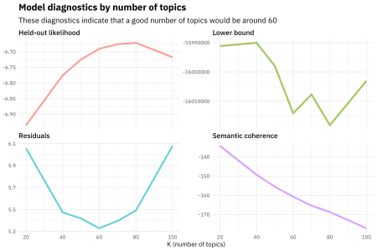

The held-out likelihood is highest between 60 and 80, and the residuals are lowest around 60, so perhaps a good number of topics would be around there.

Semantic coherence is maximized when the most probable words in a given topic frequently co-occur together, and it’s a metric that correlates well with human judgment of topic quality. Having high semantic coherence is relatively easy, though, if you only have a few topics dominated by very common words, so you want to look at both semantic coherence and exclusivity of words to topics. It’s a tradeoff.

k_result %>%

select(K, exclusivity, semantic_coherence) %>%

filter(K %in% c(20, 60, 100)) %>%

unnest() %>%

mutate(K = as.factor(K)) %>%

ggplot(aes(semantic_coherence, exclusivity, color = K)) +

geom_point(size = 2, alpha = 0.7) +

labs(x = "Semantic coherence",

y = "Exclusivity",

title = "Comparing exclusivity and semantic coherence",

subtitle = "Models with fewer topics have higher semantic coherence for more topics, but lower exclusivity")

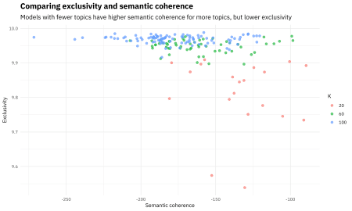

So for this analysis, it looks a good choice could be the model with **60** topics.

topic_model <- k_result %>%

filter(K == 60) %>%

pull(topic_model) %>%

.[[1]]

topic_model

## A topic model with 60 topics, 98000 documents and a 3828 word dictionary.

**Explore the topic model**

We’ve trained topic models, evaluated them, and picked one to use, so now let’s see what this topic model tells us about the Hacker News corpus. In real life analysis, this process would be iterative, moving from exploring and interpreting a model back and forth to diagnostics and evaluation in order to decide how best to model a corpus. One of the reasons I embrace tidy data principles and tidy tools is that this iterative process is streamlined. For example, let’s tidy() the beta matrix for our topic model and look at the probabilities that each word is generated from each topic.

td_beta <- tidy(topic_model)

td_beta

## # A tibble: 229,680 x 3

## topic term beta

##

## 1 1 arguments 8.56e-20

## 2 2 arguments 4.20e-15

## 3 3 arguments 3.21e-15

## 4 4 arguments 9.23e-13

## 5 5 arguments 1.45e-12

## 6 6 arguments 5.44e-18

## 7 7 arguments 1.04e-24

## 8 8 arguments 1.52e-11

## 9 9 arguments 4.77e-16

## 10 10 arguments 2.29e-16

## # ... with 229,670 more rows

I’m also quite interested in the probabilities that each document is generated from each topic, that gamma matrix.

td_gamma <- tidy(topic_model, matrix = "gamma",

document_names = rownames(hacker_news_sparse))

td_gamma

## # A tibble: 5,880,000 x 3

## document topic gamma

##

## 1 1 1 0.00631

## 2 2 1 0.00446

## 3 3 1 0.00670

## 4 4 1 0.00767

## 5 5 1 0.00742

## 6 6 1 0.00907

## 7 7 1 0.00479

## 8 8 1 0.00906

## 9 9 1 0.00801

## 10 10 1 0.00881

## # ... with 5,879,990 more rows

Let’s combine these to understand the topic prevalence in the Hacker News corpus, and which words contribute to each topic.

library(ggthemes)

top_terms <- td_beta %>%

arrange(beta) %>%

group_by(topic) %>%

top_n(7, beta) %>%

arrange(-beta) %>%

select(topic, term) %>%

summarise(terms = list(term)) %>%

mutate(terms = map(terms, paste, collapse = ", ")) %>%

unnest()

gamma_terms <- td_gamma %>%

group_by(topic) %>%

summarise(gamma = mean(gamma)) %>%

arrange(desc(gamma)) %>%

left_join(top_terms, by = "topic") %>%

mutate(topic = paste0("Topic ", topic),

topic = reorder(topic, gamma))

gamma_terms %>%

top_n(20, gamma) %>%

ggplot(aes(topic, gamma, label = terms, fill = topic)) +

geom_col(show.legend = FALSE) +

geom_text(hjust = 0, nudge_y = 0.0005, size = 3,

family = "IBMPlexSans") +

coord_flip() +

scale_y_continuous(expand = c(0,0),

limits = c(0, 0.09),

labels = percent_format()) +

theme_tufte(base_family = "IBMPlexSans", ticks = FALSE) +

theme(plot.title = element_text(size = 16,

family="IBMPlexSans-Bold"),

plot.subtitle = element_text(size = 13)) +

labs(x = NULL, y = expression(gamma),

title = "Top 20 topics by prevalence in the Hacker News corpus",

subtitle = "With the top words that contribute to each topic")

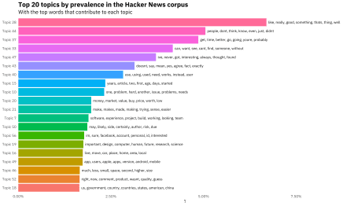

We can look at all the topics, ordered by prevalence.

gamma_terms %>%

select(topic, gamma, terms) %>%

kable(digits = 3,

col.names = c("Topic", "Expected topic proportion", "Top 7 terms"))

| **Topic** | **Expected topic proportion** | **Top 7 terms** |
| --- | --- | --- |
| Topic 28 | 0.067 | like, really, good, something, thats, thing, well |
| Topic 44 | 0.050 | people, dont, think, know, even, just, didnt |
| Topic 37 | 0.049 | get, time, better, go, going, youre, probably |
| Topic 33 | 0.042 | can, want, see, cant, find, someone, without |
| Topic 47 | 0.037 | ive, never, got, interesting, always, thought, found |
| Topic 43 | 0.031 | doesnt, say, mean, yes, agree, fact, exactly |
| Topic 40 | 0.028 | use, using, used, need, works, instead, user |
| Topic 15 | 0.023 | years, article, two, first, ago, days, started |
| Topic 10 | 0.023 | one, problem, hard, another, issue, problems, needs |
| Topic 20 | 0.020 | money, market, value, buy, price, worth, low |
| Topic 21 | 0.020 | make, makes, made, making, trying, sense, easier |
| Topic 7 | 0.019 | software, experience, project, build, working, looking, team |
| Topic 50 | 0.019 | may, likely, side, certainly, author, risk, due |
| Topic 56 | 0.018 | im, sure, facebook, account, personal, id, interested |
| Topic 19 | 0.018 | important, design, computer, human, future, research, science |
| Topic 16 | 0.017 | live, move, car, place, home, area, local |
| Topic 49 | 0.017 | app, users, apple, apps, version, android, mobile |
| Topic 46 | 0.017 | much, less, small, space, second, higher, size |
| Topic 52 | 0.017 | right, now, comment, product, wasnt, quality, guess |
| Topic 18 | 0.016 | us, government, country, countries, states, american, china |
| Topic 51 | 0.016 | year, support, last, old, next, linux, per |
| Topic 17 | 0.015 | language, programming, c, learn, python, languages, written |
| Topic 12 | 0.014 | company, business, startup, name, ideas, early, employees |
| Topic 2 | 0.014 | part, real, reason, life, story, guy, bitcoin |
| Topic 31 | 0.014 | code, open, source, write, writing, test, program |
| Topic 22 | 0.014 | pay, cost, paid, costs, paying, rate, amount |
| Topic 9 | 0.013 | email, ask, show, best, link, please, form |
| Topic 54 | 0.013 | system, large, control, systems, built, scale, require |
| Topic 55 | 0.013 | wrong, nothing, page, difference, whats, theres, view |
| Topic 26 | 0.013 | case, law, cases, nobody, wants, serious, laws |
| Topic 53 | 0.013 | change, group, history, position, political, involved, individual |
| Topic 25 | 0.012 | read, top, list, reading, add, news, books |
| Topic 11 | 0.012 | google, internet, search, browser, ie, address, chrome |
| Topic 39 | 0.012 | standard, eg, types, implementation, object, structure, table |
| Topic 42 | 0.012 | new, create, technology, website, rules, existing, created |
| Topic 38 | 0.012 | high, school, tax, average, poor, course, kids |
| Topic 30 | 0.012 | run, running, server, api, application, client, database |
| Topic 35 | 0.012 | data, information, public, access, private, analysis, details |
| Topic 48 | 0.012 | line, available, video, tools, vs, basic, tool |
| Topic 24 | 0.012 | different, true, model, definitely, yeah, left, completely |
| Topic 41 | 0.011 | service, services, provide, customers, called, trust, customer |
| Topic 36 | 0.011 | game, play, games, fun, sound, water, playing |
| Topic 34 | 0.011 | almost, fast, extremely, field, speed, tend, theory |
| Topic 5 | 0.011 | person, must, common, wonder, situation, along, net |
| Topic 29 | 0.011 | example, type, call, result, function, lack, currently |
| Topic 59 | 0.011 | number, phone, =, +, numbers, normal, random |
| Topic 60 | 0.011 | also, just, still, already, well, way, least |
| Topic 14 | 0.011 | free, windows, full, online, key, microsoft, offer |
| Topic 3 | 0.011 | work, job, state, book, jobs, leave, hire |
| Topic 27 | 0.010 | world, security, talking, rest, parts, seeing, changed |
| Topic 13 | 0.010 | web, site, post, x, os, sites, blog |
| Topic 23 | 0.010 | power, become, benefit, society, food, energy, cars |
| Topic 32 | 0.009 | often, sometimes, word, ones, words, turn, context |
| Topic 1 | 0.009 | question, level, whether, answer, questions, asked, asking |
| Topic 57 | 0.009 | set, simple, default, complex, relatively, push, implement |
| Topic 6 | 0.009 | big, companies, many, tech, deal, industry, huge |
| Topic 45 | 0.008 | content, social, network, results, media, ads, ad |
| Topic 8 | 0.008 | file, terms, legal, files, step, purpose, license |
| Topic 4 | 0.008 | women, culture, age, men, young, people, older |
| Topic 58 | 0.006 | hn, community, light, others, reddit, come, hey |

We can see here that the first several topics are focused around general purpose English words in different categories of meaning. About 10 topics down, we see a topic about markets, money, and value. A bit below that, we see the first topic with explicitly technical-ish terms like software, build, and project. There is a topic that combined “make”, “makes”, “made”, and “making”. Notice that I did not stem these words before modeling.

So there you have it! We trained topic models at multiple values of \(K\), evaluated them, and then explored our model. Let me know if you have any questions or feedback!